Installing and Using the Printek Print App
You will have two apps on your device when installed:
Print Demo – allows for printing from other app.
File Observer – allows printing of specific files when saved to a folder.

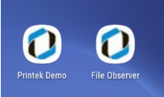
Figure 1- Icons
Print Demo

Configuring the Print Demo app:
- Open the app.
- Tap the three bars in the upper left corner. This will open the configuration screen.
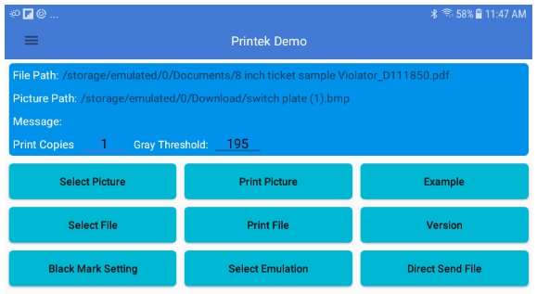
Figure 2 - Opening Screen
- Select the type of connect to the printer.
  - Bluetooth Print – verify the printer you want to connect to.
  - WiFi Print – configure the WIFI settings to match the printer.
  - USB Print
- Select the width of the paper you will be printing to.
  - 3 inch
  - 4 inch
  - 5 inch
  - 8 inch
- Tap “Connect” to select the printer.
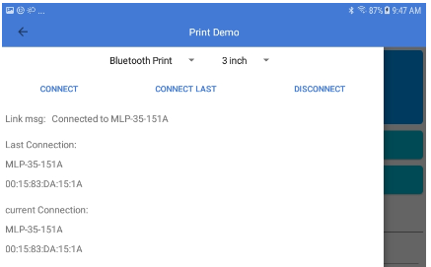
Figure 3 - Configuration Screen
- Tap the back arrow in the upper left corner after setting up the printer.
The Print Demo app is configured and ready to use.

Testing the connection:
From the opening screen you can send files to the printer to verify the connection is working. There are many options available, Print Picture – Example – Print File – Select Emulation – Direct Send File.
You can also send Simple Text, a Code 128 barcode or QRCode.

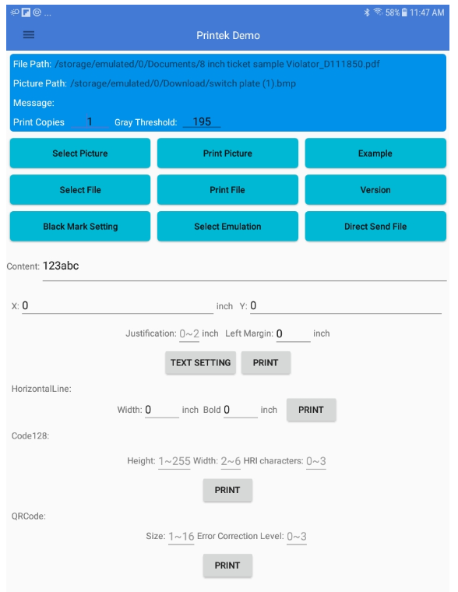
Figure 4 - Main Print Demo Screen
Print Copies -
Input the number of sample prints you want to print.

Gray Threshold –
Sets the threshold between black and white when using Threshold Print.

To Print a Picture from your device -
Tap “Select Picture” to view the pictures on your device.
Select the picture you want to print.
Tap “Sure” once you have selected the picture you want to print.
Tap “Print Picture”.
Select the Print Mode, Threshold or Bayer Matrix Ordered Dither.
  - Threshold is good for line drawings.
  - Bayer Matrix Ordered Dither allows for grayscale printing.

To print an sample print –
Tap “Example” to print the sample print from the app.

To Print a file from your device -
Tap “Select File” to view the files on your device.
Select the file you want to print.
Tap “Print File”.

Other Options-

Black Mark Sensing –
This will allow you to set the printer to use black mark paper.
The bottom of the Demo Program allows you to print one line of Text, a Code123 Barcode or a QR code.

Select Emulation-
Sends the file to the printer using the emulation mode that the printer is set to.

You can also type simple

Type the data into the Content Line. There are three options for printing the data:

- Data Placement:
- X: = horizontal
- Y: = vertical
- Justification or Left Margin settings
- Text Setting – Underline, Double Width, Double Height and Bold settings

- Code128 perimeters
- Height
- Width
- HRI characters

- QRCode parameters
- Size
- Error Correction Level

Printing from another app –
Once the Demo app is setup you can print from other apps that allow printing. Open a program that you want to print from. Depending on the program you should see three dots in the upper right corner of the app. Tap on the dots you should have a Print option. Once you tap Print the Print Demo app should open.
The app will show the printer with options to select how many copies to print and the paper size. Change the selections if you need/want to.
Tap the print icon to print.

File Observer

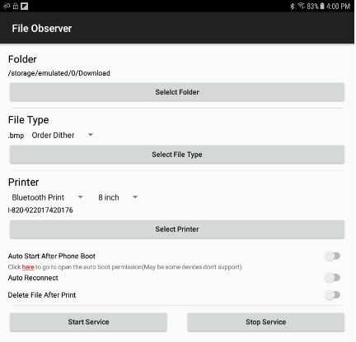
Figure 5 - File Observer Main Screen
Configuring the File Observer app:
- Folder:
  - Tap “Select Folder” bar to select the folder you want the app to monitor. This should be the folder where you will save the files.
- File Type:
  - Tap “Select File Type” bar to select the type of file the app will print.
  - When select a file type other than .txt you have the option of Order Dither or Threshold printing.
    - Order Dither uses gray scaling when printing.
    - Threshold uses black and white printing.
- Printer:
  - Select the connection type and select the printer and printer settings.
  - Select the size paper.
  - Tap “Select Printer” bar to select the printer you want to print to.

There are three options you can enable:
  - Auto Start After Phone Boot - App will automatically start when the device is turned on. The printer must be turned on to reconnect.
  - Auto Reconnect – App will reconnect to the printer if you go out of range of the printer. The printer must be on for this function to work.
  - Delete File After Print – app will delete the file from folder after it is printed instead of saving the file.

Tap the “Start Service” bar to start the app. You will see an icon in the upper left corner of your device indicating the app is running in the background.
When you save the file type you selected to the folder you selected another icon will appear indicating the app is preparing the file for printing.

